MODULE: 2 (HTML)
- Define the terms: Website, Webpage, Web browser, Web server, HTML, CSS.
Ans:-
- Website:- A Website is a collection of related webpages stored on a web server and accessed through the internet using a domain name.

- Webpage:-A Webpage is a single page of a website that is written using HTML and displayed in a web browser.

- Web Browser:- A Web Browser is a software application used to access and display webpages on the internet.

- Web Server:- A Web Server is a computer or software that stores websites and delivers webpages to users when they request them through a browser.

- HTML:- HTML (HyperText Markup Language) is the standard language used to create and structure webpages.

- CSS:- CSS (Cascading Style Sheets) is used to style and design webpages such as colors, layout, fonts, spacing, and responsiveness.

- Display top 10 IT companies list in html webpage.
Ans:-


- Create a webpage to show “This is my first HTML page”
Ans:- 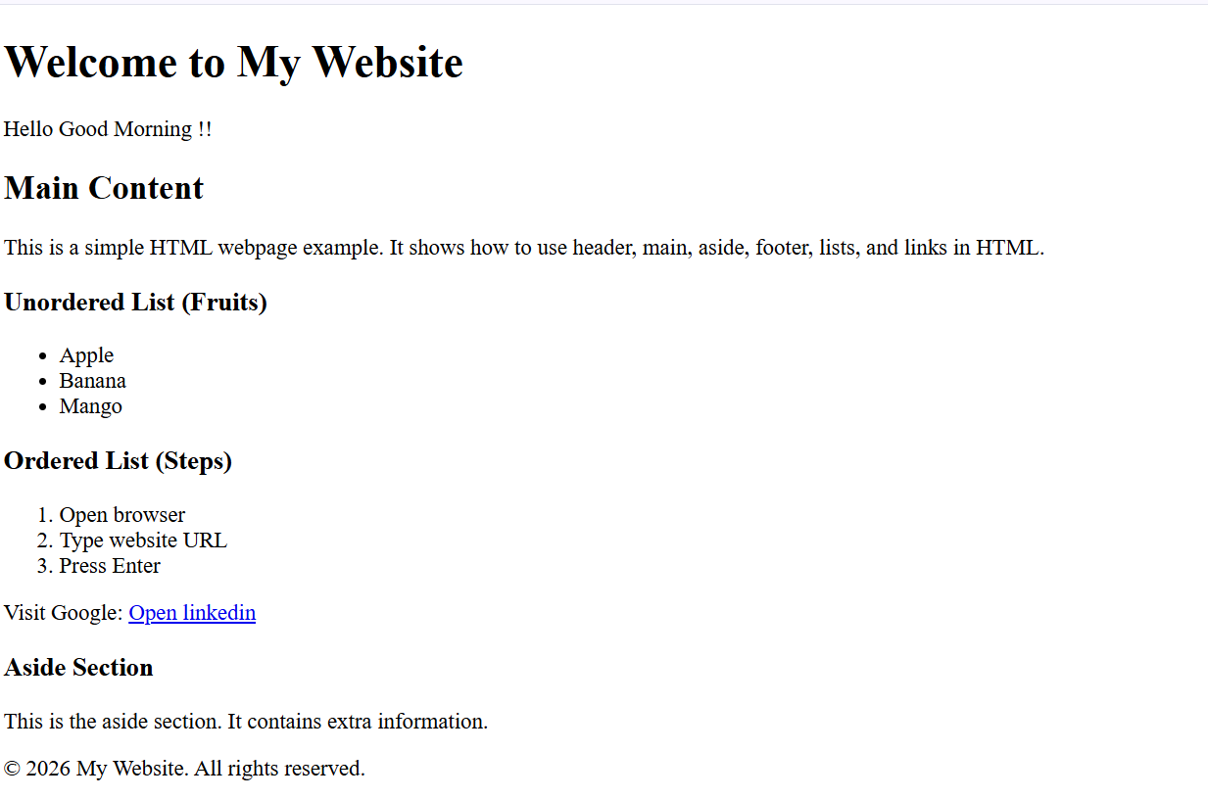
- Create a dropdown list.
Ans:-
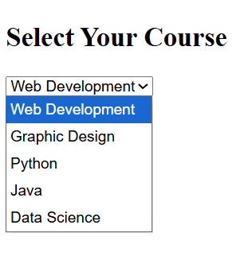
- Create a Table Of college Management system using row span & col span.
Ans:-
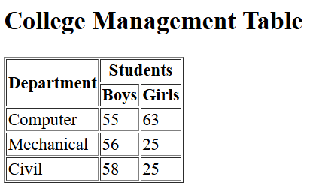
- Create below table using HTML table tags.
Ans:- 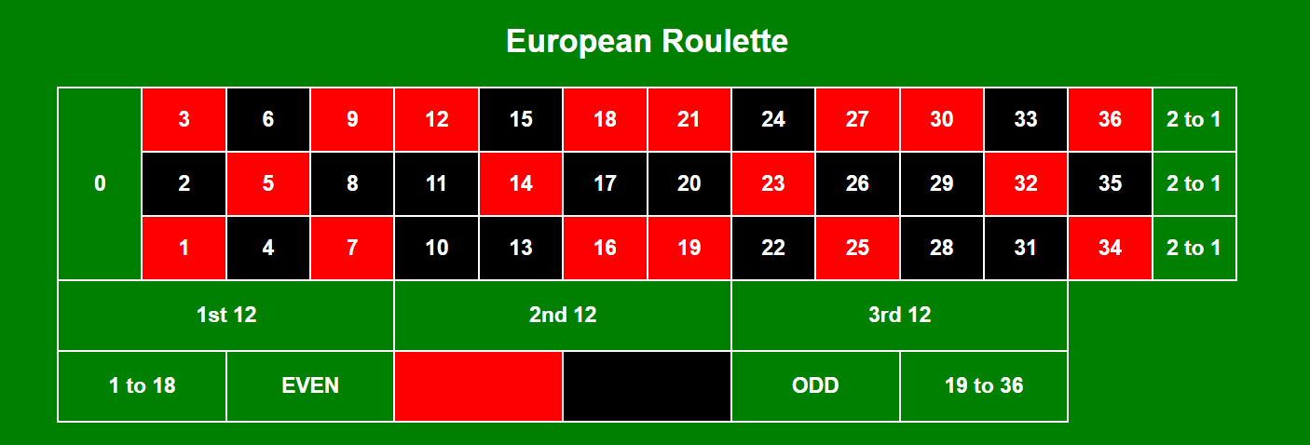

- Create Registration form using HTML, CSS.
Ans:-
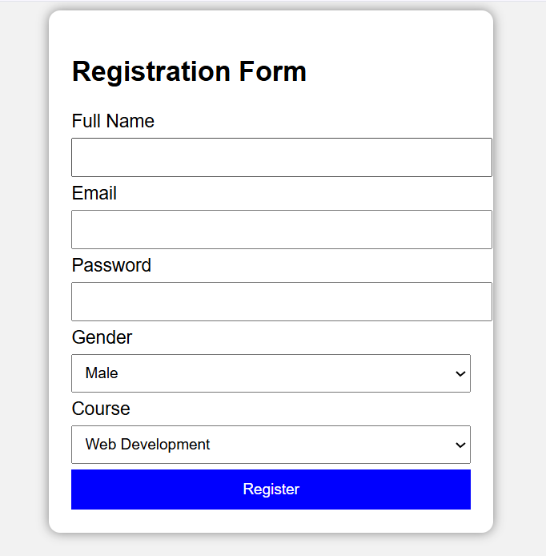
- In how many ways can a CSS be integrated as a web page?
Ans:-
1. Inline CSS:-
CSS is written inside the HTML element using the style attribute.
Example:-
<p style="color:red; font-size:20px;">This is Inline CSS</p
2. Internal CSS:-
CSS is written inside the <style> tag in the <head> section of the HTML document.
Example:-
<!DOCTYPE html>
<html>
<head>
<style>
p{
color:blue;
font-size:20px;
}
</style>
</head>
<body>
<p>This is Internal CSS</p>
</body>
</html>

3. External CSS:-
CSS is written in a separate .css file and linked to the HTML page.
HTML File
<link rel="stylesheet" href="style.css">
style.css
p{
color:green;
font-size:20px;
}
- Create simple three pages using External CSS, Internal CSS, and Inline CSS.
Ans:-
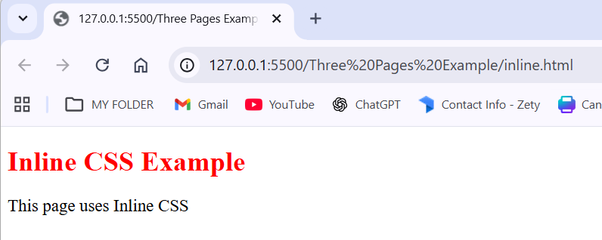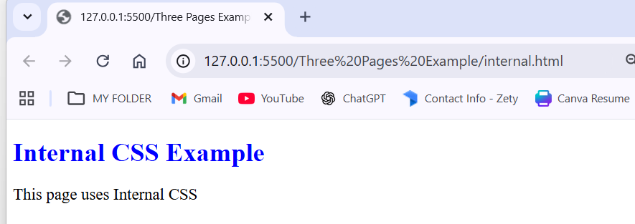
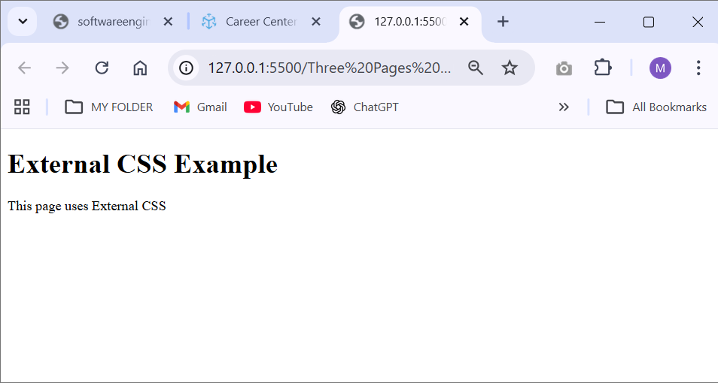

- Create below page using HTML CSS.
Ans:-
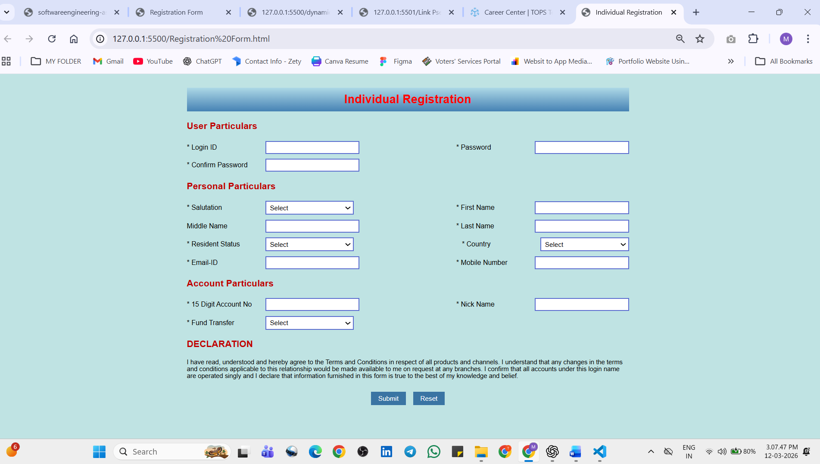
- Create link-pseudo classes using external css, to format links on the pages.
Ans:-
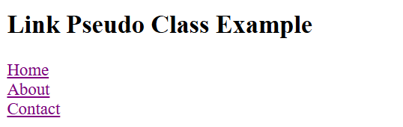
- Create a dynamic pseudo class using HTML, CSS.
Ans:- 